**Dual Convolutional Neural Networks of Ensemble learning with Attention Mechanism for Classification Task**

**using Fruits-360 Dataset**

**Abstract**

Deep learning, as a cutting-edge modern technology for computer vision, holds significant potential in image classification. As a crucial step in the sale of fruits, fruit classification is a limiting factor in the development of the commercial market economy. Utilizing computer vision technology for the automatic classification of fruits can address the shortage of human resources and effectively enhance the efficiency of post-harvest fruit processing. This study focuses on the classification of multi-class fruits, customizing an improved Inception module using asymmetric convolution and an improved ResNet module using depthwise separable convolution. Two convolutional neural network models based on these modules are combined into a new model. Furthermore, the SE attention mechanism is added to enhance the robustness of classification across multiple classes. After 40 epochs of training, the model achieved a maximum accuracy of 99.97% and recall of 98.44% on the test set. Compared to models proposed by other literatures and four popular CNN models trained with the same dataset and training steps under identical computational resources, it still exhibits the most powerful classification performance.

**Keywords:** Fruit Images Classification; CNN; SE Attention Mechanism; Ensemble learning

# **Introduction**

In practical scenarios, a multitude of complex tasks and applications in computer vision fundamentally rely on image classification [1]. Fields such as modern medicine, autonomous driving, e-commerce platforms, and facial recognition all require the use of image classification technology. The swift advancement of modern image classification technology has led to the creation of numerous outstanding image classification algorithms. Whether it's the residual neural networks proposed in 2015 based on the concept of information direct connection [2], or the Squeeze and Excitation network proposed in 2017 based on human visual characteristics [3], both have surpassed the level of human eye recognition, demonstrating the high classification accuracy of deep learning in image classification.

As an integral component of modern agricultural technology, fruit image recognition research has primarily focused on assessing fruit maturity and detecting pest infestations [4]. However, the study of fruit classification has frequently been overlooked [5]. Traditional fruit classification requires manual inspection, which not only relies on a significant amount of human labor but also results in low classification efficiency and high error rates [6]. Using advanced image classification technology can efficiently address this issue. Additionally, in a context where the diversity of fruit types and the development of improved varieties are escalating, machine-based recognition of various fruits to improve classification accuracy is emerging as a new area of research interest [7]. In addressing the issue of fruit classification, this paper contributes the following:

* An ensemble model composed of two distinct Convolutional Neural Networks was constructed for fruit classification, combining one model based on an enhanced Inception block and another based on the ResNet block improved by depthwise separable convolutions.
* In an effort to enhance the model's focus on crucial regions of fruit images, the Squeeze and Excitation attention mechanisms are added into the constructed ensemble model, resulting in improved fruit classification capabilities.

This report is structed as follows. Section 2 introduces the current study of deep learning in fruits classification. Section 3 provides the dataset, data preprocessing and the architecture of the ensemble model. Section 4 analyzes the performance of this model with various evaluation metrics and compares it with other excellent models. Section 5 concludes my scheme and proposes some future improvements.

# **Related work**

In the field of computer vision, Convolutional Neural Networks (CNNs) have been widely applied and have taken a dominant position. Krizhevsky et al. [8] introduced the AlexNet network model in 2014, incorporating Dropout layers to mitigate overfitting in models, leading to a surge in the rapid evolution of CNNs. Simonyan et al. [9] proposed the VGG network model, which increased model depth through the use of small convolutional kernels, effectively enhancing model performance. He et al. [2] proposed ResNet reduces the adverse impact of depth on feature learning by directly adding the input to the output.

As attention mechanisms were successfully introduced in natural language processing, researchers began incorporating them into image classification tasks, offering new ideas and potential for performance improvement [10]. Wang et al. [11] used attention mechanism in conjunction with residual networks, leading to adaptively changing attention ability in various modules as network layers deepened, focusing on important weights at deeper levels. Haut et al. [12] merged visual attention with deep convolutional networks, enabling the network to filter and capture more critical features. Dosovitskiy at al. [13] proposed the Vision Transformer, which is a convolutional neural network based on the self-attention mechanism. It segments images into fixed-size patches and passes them to a Transformer encoder to address long-distance relationships in images, often outperforming traditional CNNs.

To further explore the application of CNNs in fruit classification tasks, Hossain et al. [5] designed a lightweight CNN model with 6 convolutional layers, achieving an accuracy of 85.43% when classifying random fruit images on the network. Zhang et al. [14] introduced a 13-layer CNN model and tested on the self-built fruit dataset. They used three data augmentation techniques to enhance the dataset, increasing the overall accuracy to 94.94%. Muresan et al. [15] developed a CNN with 4 convolutional layers, 4 pooling layers, and 2 fully connected layers for classifying 60 fruit types, achieving an enhanced accuracy of 96.3%.

# **3. Material and Method**

## **3.1 Dataset**

As a crucial factor in computer vision, the quality of data contained in datasets greatly affects the performance of deep learning networks [1]. The image data in Fruits-360 dataset on Kaggle is collected using the same equipment in a uniform environment, resulting in less variability in image specifications and higher image quality. Hence, the images used in this report are sourced from the Fruits-360 dataset on Kaggle. This dataset contains 131 classes of 67 fruit types, covering a majority of fruit varieties. But some classes are further subdivisions of a single fruit type. All the classes and the corresponding samples are shown in Figure 1.

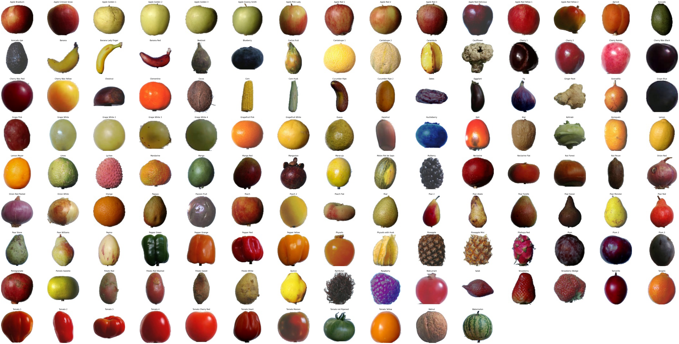

Figure 1. Sample Pictures of Each Fruit Class In fruits-360 Dataset

There are 90,483 images in Fruits-360 dataset, among which 67,692 are used for training and 22,688 for testing. While the overall number of images is high, the number of images per class is not balanced due to 131 classes. For instance, there are 1,312 images in the Grape Blue class compared to just 396 images in the Ginger Root category. Therefore, utilizing data augmentation techniques to increase training data volume and enhance the model's generalizability is essential.

### **3.1.1 Data preprocessing**

To replicate real-world photography settings, input images are random rotated from 0 to 30 degrees and random translations of 20% in horizontal and vertical directions, simulating positional variances in image capture. Subsequently, random scaling ranging from 85% to 115% and random horizontal flipping are applied to improve robustness. After these image transformations, the new areas of the pictures are filled using nearest-neighbor interpolation.

Aiming to reduce the influence of noise from white backgrounds on model generalization, a threshold of 240 is used to create a binary image of the background, which is then converted back to RGB format to replace the original image's background. Moreover, resizing all input data to 100x100 and using Min-Max normalization to adjust image pixel values from their original range to between 0 and 1, enhancing the model's convergence speed.

To confirm the efficacy of this data preprocessing approach, a control experiment was conducted using the same data split ratios and the same model, with the experimental performance shown in Figure 2.

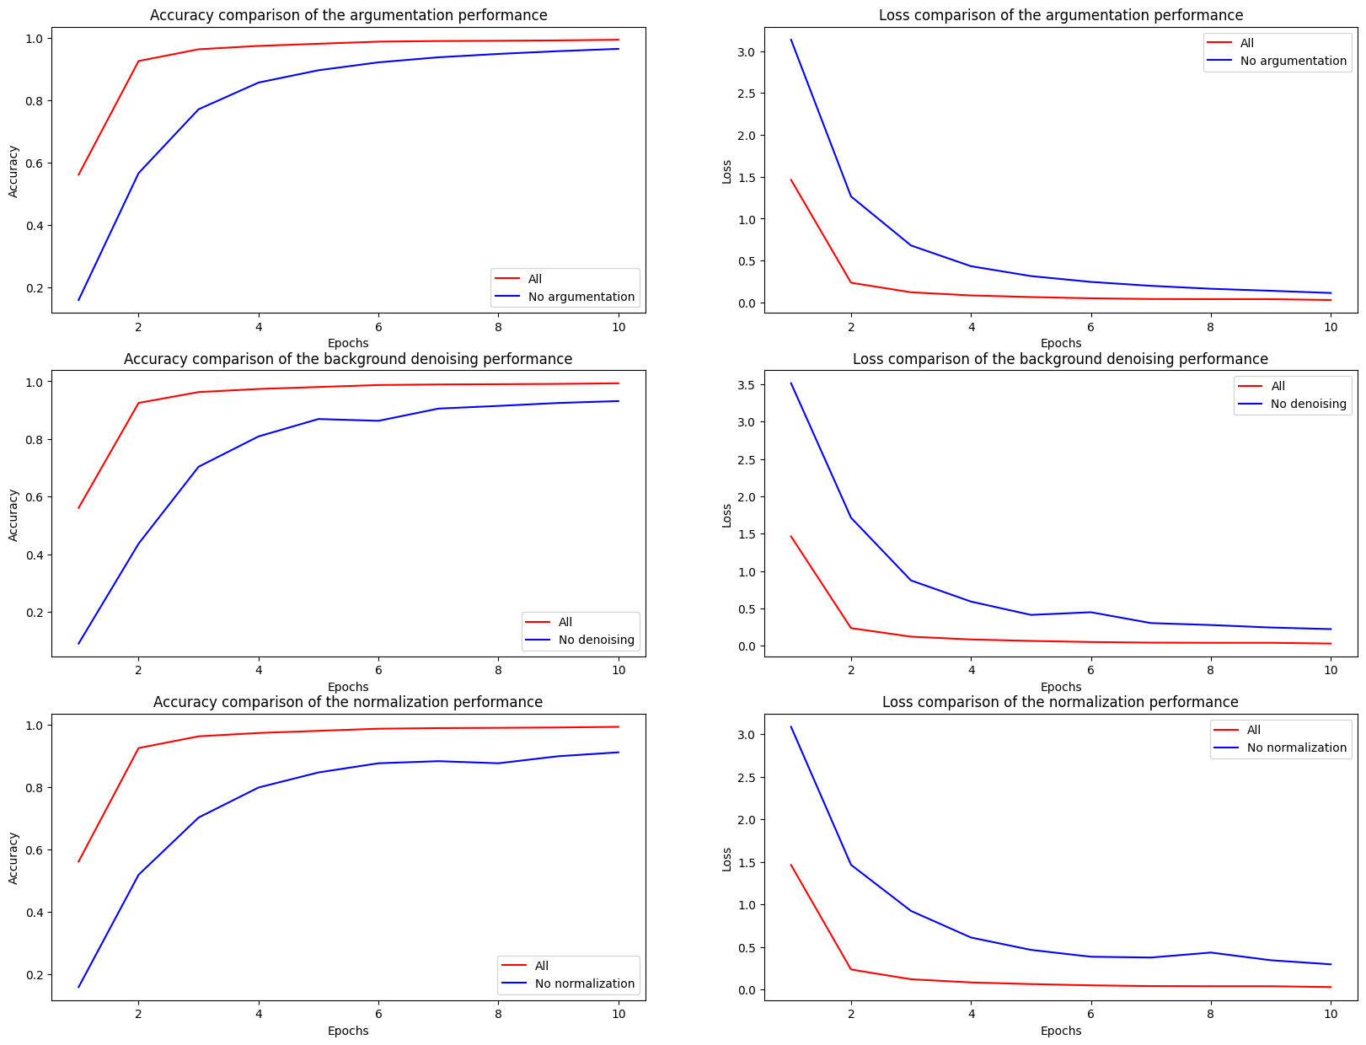

Figure 2. Performance Metrics for Different Data Preprocessing Techniques

Each pair of the above figures compares the performance of models with and without the use of specific techniques for data preprocessing. From these three pairs of graphs, it is evident that omitting any data preprocessing technique would reduce the model accuracy and slow down the convergence of loss values, indicating that data augmentation, normalization, and background denoising all contribute to more effective learning from the training data.

### **3.1.2 Data split**

For evaluating and enhancing the model's performance, the data was partitioned into training, validation, and testing sets. The training set, holding the majority of the data, is input into the model to facilitate learning the features and differences of various fruit classes. The validation set is used for tuning the model's hyperparameters, assisting in selecting the optimal model architecture during the training process. The test set is used to evaluate the trained model and is only used once during the evaluation phase.

However, due to variations in datasets and models, there is no standard split ratio for all studies. Consequently, this report establishes three comparative experiments to determine a suitable data split ratio. Data in the training folder is split into training and validation sets of varying ratios, while the 22,688 images in the test folder are designated as the test set. Three comparative ratios are set at 60%:15%:25%, 65%:10%:25%, and 70%:5%:25% respectively.

The comparative experiment involves training data from three ratios with the same data augmentation on the same model and epochs, with results shown in Figure 3.

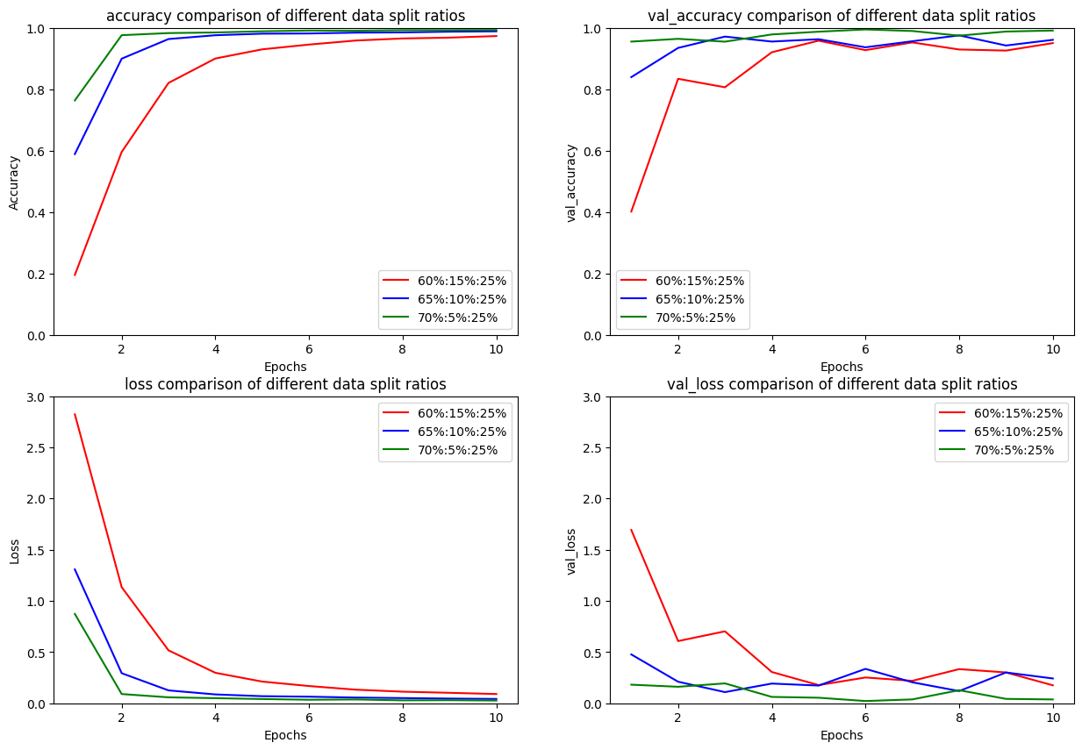

Figure 3. The Loss and Accuracy Comparison of Three Different Data Split Ratios

The comparison of four graphs demonstrates that the data split ratio of 70%:5%:25% yields both high accuracy and low loss in validation, indicating good generalization. Additionally, models trained with different data split ratio are evaluated using the test set, with a comparison of classification accuracy and loss for the test set as shown in Figure 4. Comparing the model performance of three data split ratios, the model with the 70%:5%:25% split ratio continues to exhibit the highest test accuracy and the lowest test loss, leading to the conclusion that the 70%:5%:25% division of the dataset is an excellent split ratio.

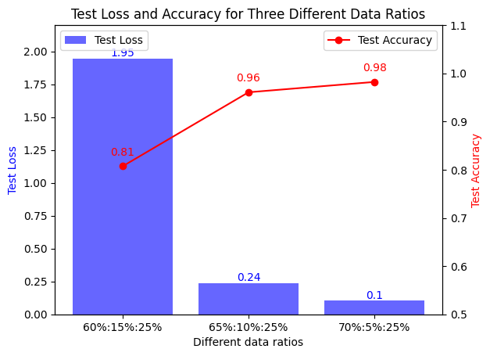

Figure 4. The Test Loss and Accuracy for Three Different Data Split Ratios

## **3.2 Proposed Model**

### **3.2.1 Ensemble Model**

In this study, an ensemble model is designed based on two different CNN models. Each CNN model would be introduced next. The overall architecture of the ensemble model is shown in Figure 5.



Figure 5. The Network Architecture of The Ensemble Model

This ensemble model concatenates the output tensors of two CNN models along the channel axis first, aiming to glean more comprehensive information from multiple models. Then, the synthesized features are merged through two fully connected layers with 128 and 64 nodes respectively, transforming the local features of the convolutional neural network into global information. To enhance the model's generalizability and prevent overfitting, Dropout layers with a dropout rate of 0.3 are added after each of the two fully connected layers to randomly discard some neuron outputs, and two batch normalization layers are included to increase the model's stability. Lastly, SoftMax is applied to transform the output into a probability distribution across different categories.

### **3.2.2 Squeeze and Excitation attention mechanism**

The Squeeze-and-Excitation (SE) module can be categorized into three main parts, as shown in Figure 6.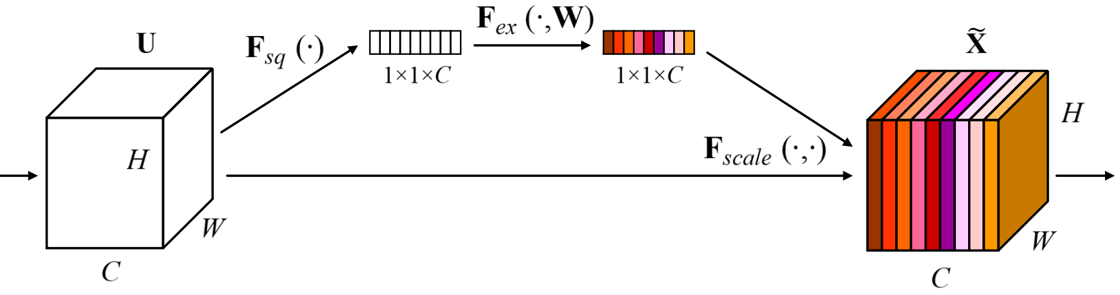

Figure 6. The structure of the Squeeze and Excitation block(Squeeze-and-Excitation Networks) [3]

Initially, during the Squeeze phase, global average pooling transforms each two-dimensional feature channel into a real number $Z_{c}$, enabling lower convolutional layers to exploit information from the global receptive field. The equation is as follow:

$$\begin{aligned}zc​=F_{sq}\left(u_{c}\right)=\frac{1}{H×W}\sum_{i=1}^{H}{\sum_{j=1}^{W}{uc​\left(i,j\right)}}\#\left(3-1\right)\end{aligned}$$

In equation 3.1, $u_{c}$ denotes the feature map of the channel *c*. *H* and *W* denote the height and width of the feature map, respectively. Then, in the Excitation phase, weights *s* for each feature channel are generated using parameters *W*, using a concept based on the gating mechanism in RNNs, enabling the network to integrate information from feature maps of each channel. The equation is as follow：

$$\begin{aligned}s=F_{ex}\left(z,W\right)=σ\left(g\left(z,W\right)\right)=σ\left(W2​δ\left(W1​z\right)\right)\#\left(3-2\right)\end{aligned}$$

In equation 3.2, W1 and W2 are fully connected layers. $​δ$ represents the Relu activation function and $σ$ denotes the sigmoid activation function. Lastly, in the Reweight phase, the output weights from the Excitation phase are used as indicators of the importance of each feature channel. The recalibration of original features on the channel dimension is achieved by multiplying feature channels with respective channel weights, thus assigning weights to the features. The equation is as follow:

$$\begin{aligned}U_{c}=F_{scale}\left(z,W\right)=σ\left(u_{c},s_{c}\right)=s_{c}∙u_{c}\#\left(3-3\right)\end{aligned}$$

In this equation, $s_{c}$ represents the weight of channel *c*. In this study, the SE attention mechanism is introduced in two CNN models. With a minor increase in the number of parameters, different weights are assigned to various parts of the input images, making the models attentive to more important features and resulting in more accurate classification.

**3.2.3** **Component Model 1**

The initial layer of the model consists of a convolutional layer with a 3x3 kernel, designed to extract initial features from the input fruit images. Subsequently, a batch normalization layer and a max pooling layer with 2x2 kernels are added to accelerate convergence speed and reduce the size of the feature maps. Then, the model processes through three layers of custom Inception modules to extract fruit features on various scales. Last, a max pooling layer and a global average pooling layer transform the three-dimensional feature map into a one-dimensional feature vector, preparing for feature concatenation. Figure 7 is the network architecture of this model.

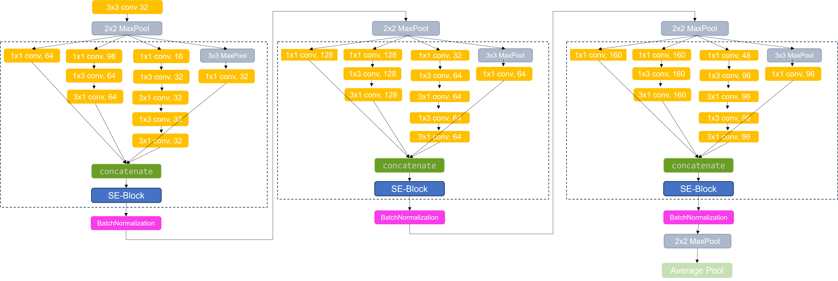

Figure 7. The Network Architecture of The Component Model 1

In this model, the custom Inception module decomposes the Inception module's convolutional layer with a 7x7 kernel into two convolutional layers with a 3x3 kernel, enhancing the model's non-linearity while preserving the receptive field and capturing spatial characteristics. Then, asymmetric convolution is applied to replace the convolutional layer with a convolutional layer with 1x3 kernel and a convolutional layer with 3x1 kernel, further reducing the network's parameters and lowering computational cost and training time. The comparison of the structure before and after improvement is shown in Figure 8.

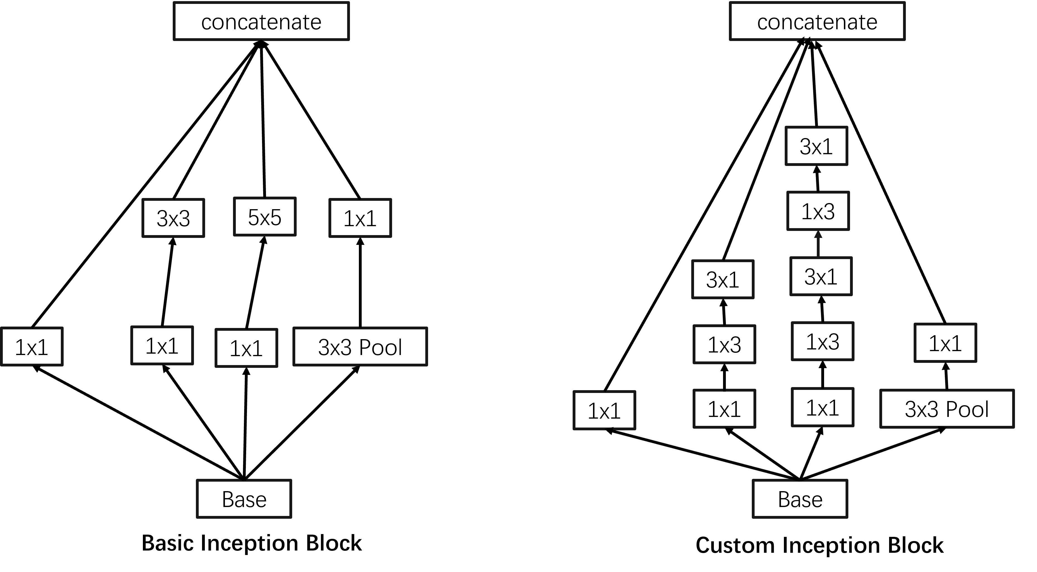

Figure 8. The Architecture of Inception Block (left) And the Custom Inception Block (right)

Additionally, I add the SE attention mechanism after the Inception block, allowing the combined features from convolutional kernels of different scales to be reweighted based on their relevance to classification, making the model more attentive to features that are crucial for classification. Ultimately, the complete custom Inception block is presented in Figure 9.

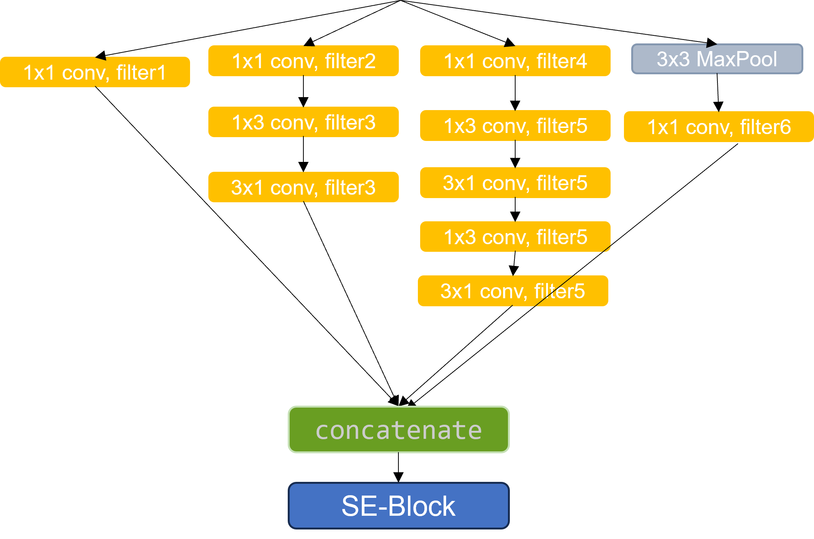

Figure 9. The Architecture of The Complete Custom Inception Block

### **3.2.4** **Component Model 2**

The architecture of the second component model is shown in Figure 10, built with four custom residual blocks. The input images first pass through a convolutional layer with 7x7 kernel size to extract image features with a larger receptive field. Then, a batch normalization layer and a RELU layer are added to mitigate the issue of gradient vanishing. A max pooling layer with a 2x2 kernel size is then used to decrease the spatial dimensions of the features. Afterwards, four custom residual blocks are used to learn deeper features of the input images. The output of four residual blocks with progressively increasing filters is inputted to a max pooling layer with 2x2 pooling kernel to further diminish the dimensions of the feature map. Finally, a global average pooling layer is used to suppress overfitting.

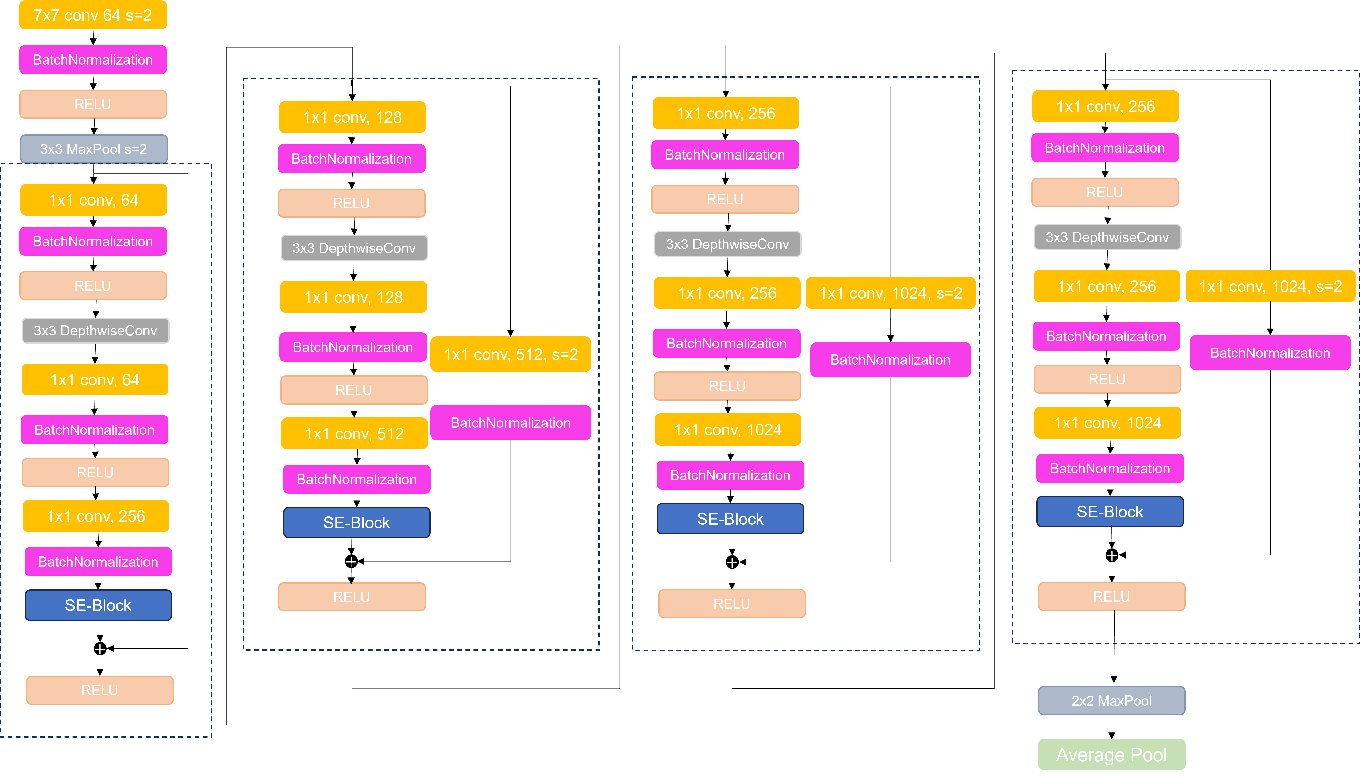

Figure 10. The Network Architecture of The Component Model 2

The custom residual block primarily introduces depthwise separable convolutions on the basis of the original ResNet, replacing the traditional convolutions with 3x3 convolutional kernel, effectively reducing computational load and parameters. The network structure of the custom residual block is shown in Figure 11.

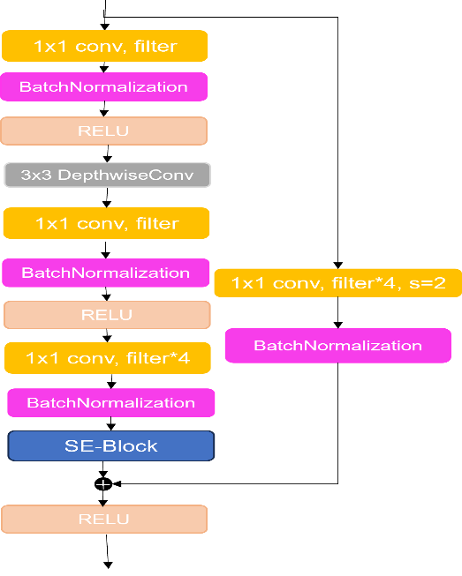

Figure 11. The Architecture of The Complete Custom Residual Block

Depthwise separable convolution consists of two parts. The first part is depth convolution, using a single convolutional kernel for each channel of the input feature map. The number of kernels corresponding to the number of channels in the previous layer, ensuring a one-to-one correspondence between channels and kernels. The second part is pointwise convolution, using a convolutional layer with 1x1 kernel to perform a weighted combination of the output from depth convolution, achieving feature fusion across different channels. The computational steps for depthwise separable convolution compared to standard convolution is presented in Figure 12.

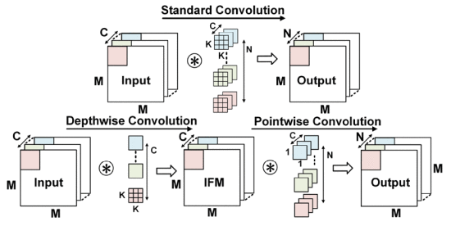

Figure 12. Standard convolution versus depthwise separable convolution. [2]

To visibly illustrate the comparative reduction in computation between depthwise separable convolution and standard convolution, the following is the ratio equation for two convolution layers:

$$\begin{aligned}\frac{S_{sc}}{S_{conv}}=\frac{D×D×C×K×K+D×D×C×N}{D×D×C×N×K×K}=\frac{1}{N}+\frac{1}{K^{2}}\#\left(3-4\right)\end{aligned}$$

In the equation, C and D signify the channels and dimensions of the feature map. N and K represent the quantity and size of the convolution kernels. According to equation 3-4, the use of depthwise separable convolution notably decreases computational demands, particularly at comparable depths, making the network more efficient and enhancing classification effectiveness.

Apart from this improvement, I have also added the SE attention mechanism just a step before the addition operation in the residual connection, inputting the feature map from the convolution layer into the SE module to amplify the model's focus on important features. The output feature map highlighting important features is then merged with the original input features, fully leveraging the attention mechanism while retaining the core advantages of the residual network.

### **3.2.5 Model Training**

To maximize the performance of ensemble model, I conducted experiments concerning the loss function, optimizer, and number of training epochs to select the most suitable hyperparameters.

#### Loss function

Acting as a metric for the disparity between predicted and actual labels, the loss function is key in training model direction. With 131 image classes in this study, I customized the cross-entropy loss function for the multi-classification problem and compared it with the in-built cross entropy function. Figure 13 displays the experimental comparison results.

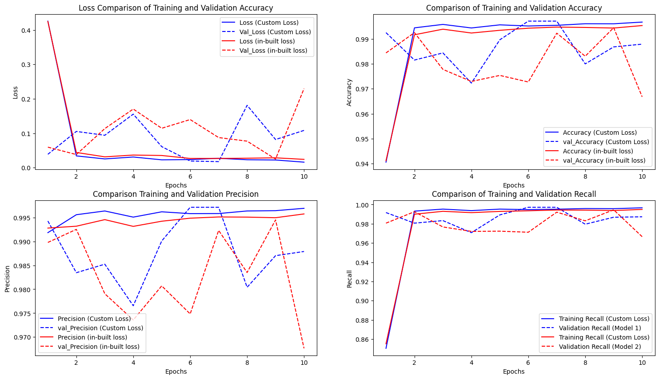

Figure 13. Comparison Of Evaluation Metrics Between In-built Loss Function and Custom Loss Function

The comparison plots from the above figure indicate that the custom cross entropy loss function exhibits comparable performance to the in-built cross entropy loss function both in training and testing, validating the effectiveness of this custom loss function.

#### Optimizer

Training the model involves perpetually refining weights for accurate classification, and the optimizer adjusts these weights in response to the model's loss to minimize it. I utilized two adaptive learning rate optimizers, RMSprop and Adam. For comparison, setting the initial learning rate for both at 0.001 and training with the same model. The training results are shown in Figure 14.

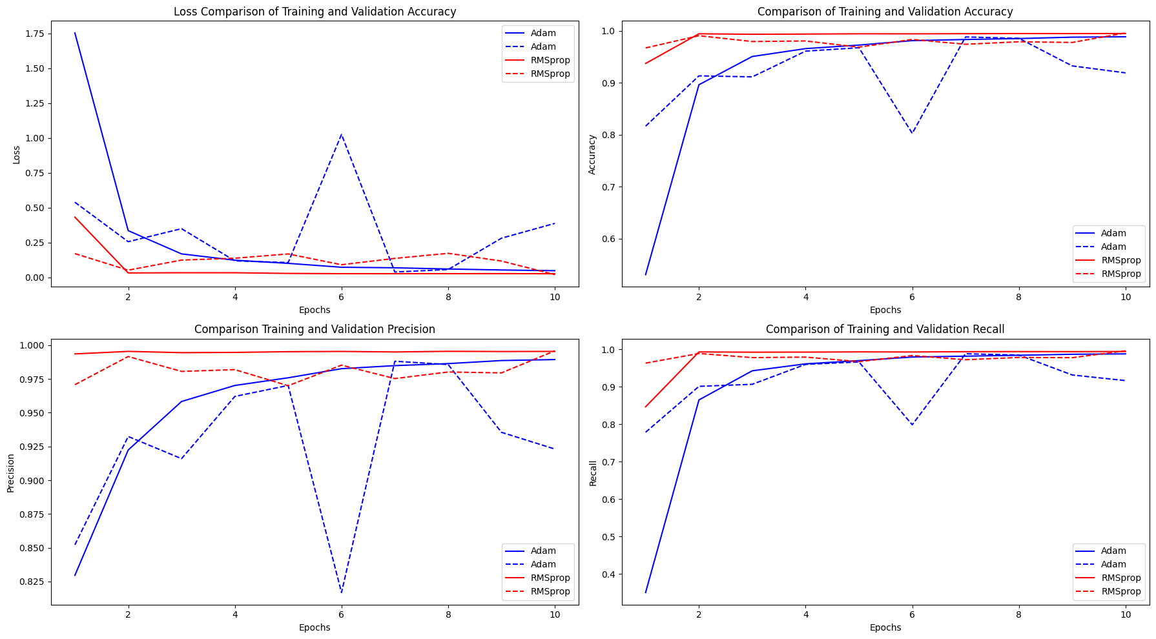

Figure 14. The Performance of The Model on The Training Set and Test Set with Different Optimizers

The comparison based on four evaluation metrics shows that the RMSprop optimizer is more consistent throughout the training, as evidenced by the stability in all four curves. On the other hand, the Adam optimizer is less stable, with its accuracy, precision, and recall rates on the validation set are all lower than RMSprop. Hence, RMSprop is the suitable option for this research.

#### Epoch Settings

During model training, the setting of epochs significantly impacts the training effectiveness. Too few epochs mean the model doesn't get enough data to learn from the input images, potentially missing complex relationships and under converging. Conversely, too many epochs can lead to overfitting on training data, resulting in poor performance on test data. I trained the defined model for 50 epochs, saving the model at the 10, 20, 30, 40, 50 epoch intervals for further evaluation. The experimental results are shown in Figure 15.

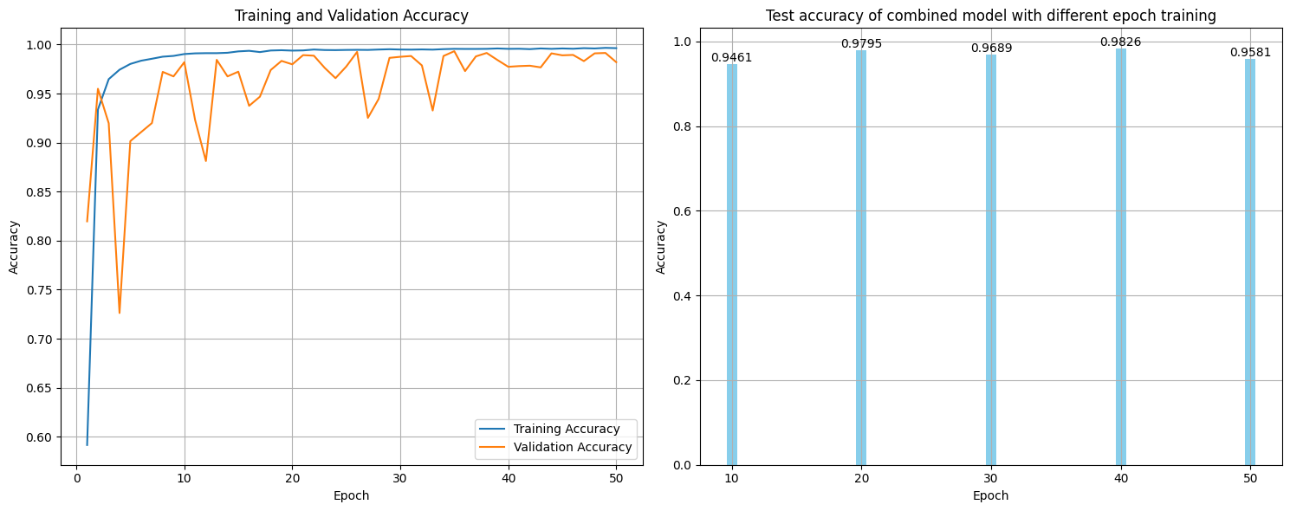

Figure 15. The Performance of The Model on The Training Set and Test Set with Different Training Epochs

From the perspective of accuracy during training and validation, the accuracies of each epoch are closely matched, with no noticeable decline in validation accuracy. Looking at the test results, the 40-epoch mark appears to be a turning point. Beyond 40 epochs, the model's testing accuracy only marginally exceeds that of a 20-epoch trained model. For epochs fewer than 40, there is still room for enhancement in the model's generalizability. In summary, the model trained with 40 epochs demonstrates optimal overall performance, with a test set accuracy of 98.26%.

## **3.3 Evaluation Strategy**

In order to evaluate the model implemented in this paper from different perspectives, the Gradient-weighted Class Activation Mapping (Grad-CAM) method is used to visualize the attention areas of the model, and ten evaluation metrics are used to measure the model's performance. These include Loss, Accuracy, Precision, Recall (Sensitivity), Specificity, F1-score, Kappa, Confusion Matrix, ROC-AUC curve, and the precision-recall curve. The equations involved in calculating each of these evaluation metrics are presented below:

$$\begin{aligned}L\left(y,y^{​}\right)=-\frac{1}{N}\sum_{n=0}^{N-1}{\sum_{c=0}^{C-1}{y_{n,c}\log\left(p_{n,c}\right)}}\#\left(3-5\right)\end{aligned}$$

In equation 3-5, N denotes the count of input images, and C indicates the number of classes.

$$\begin{aligned}Accuracy=\frac{TP+TN}{TP+TN+FP+FN}\#\left(3-6\right)\end{aligned}$$

In equation 3-6, TP stands for true positives, where the data is a positive sample and is identified as such. TN denote data correctly identified as negative samples, FP represents negative samples incorrectly identified as positive, and FN indicates positive samples incorrectly identified as negative.

$$\begin{aligned}Precision= \frac{TP}{TP+FP}\#\left(3-7\right)\end{aligned}$$

$$\begin{aligned}Recall \left(Sensitivity\right)= \frac{TP}{TP+FN}\#\left(3-8\right)\end{aligned}$$

$$\begin{aligned}Specificity = \frac{TN}{TN+FP}\#\left(3-9\right)\end{aligned}$$

$$\begin{aligned}F_{1}-score= \frac{2×Rrecision×Recall}{Precision+Recall}= \frac{2TP}{2TP+FP+FN}\#\left(3-10\right)\end{aligned}$$

$$\begin{aligned}Kappa= \frac{P_{0}-P_{e}}{1+P_{e}}\#\left(3-11\right)\end{aligned}$$

In equations 3-11, $P_{0}$ stands for the observed accuracy, namely the ratio of the model's predictions that are consistent with the actual labels. Pe denotes the expected accuracy, which is the proportion of predictions matching the true labels under the assumption of random prediction by the model.

## **3.4. Environment Execution**

All the experiments and model training mentioned in this study are run on the equipment with AMD Ryzen 5 4600H with Radeon Graphics 3.00 GHz. This device is equipped with an Nvidia GeForce GTX 1650 chip and the operating system is Lenovo Windows 11.

# **4. Experimental Results**

## **4.1. Performance Results using the dataset**

**4.1.1 Loss**

During training, a lower loss value signifies that the model's predictions are closer to the actual values. The loss curve graphically represents the model's convergence rate and the variability of the curve reflect the stability of the model's training. The loss value curve of the ensemble model is shown in Figure 16.

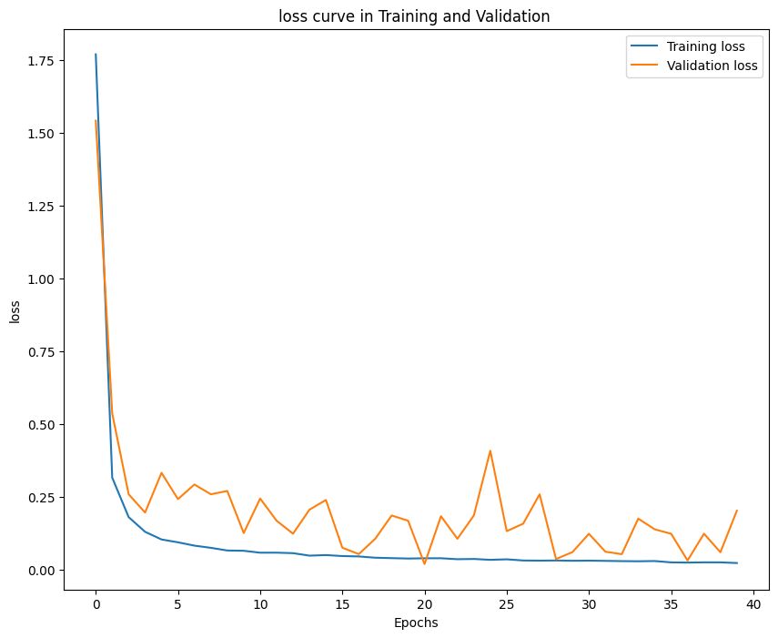

Figure 16. The Loss Curve of The Ensemble Model in Training and Validation

Initially, as the model learns the features of input images, the loss value quickly reduces. With ongoing training, the training loss steadily declines and converges to an optimal level. On the validation set, the curve sometimes fluctuates slightly, likely due to data distributed across different batches. But after multiple epochs of training, the model's performance stabilizes, and the loss value on the validation set gradually becomes steady. The model's loss value on the test set is similar to that in the later stages of training, achieving 0.1380.

**4.1.2 Accuracy**

As an indicator that intuitively reflects the model's correct classification of samples across the entire dataset, accuracy is applicable to various computer vision areas. In this study, a custom accuracy function is used to calculate the accuracy during training. The calculation formula is shown in equation 3-6. The accuracy curve of the model is shown in Figure 17.

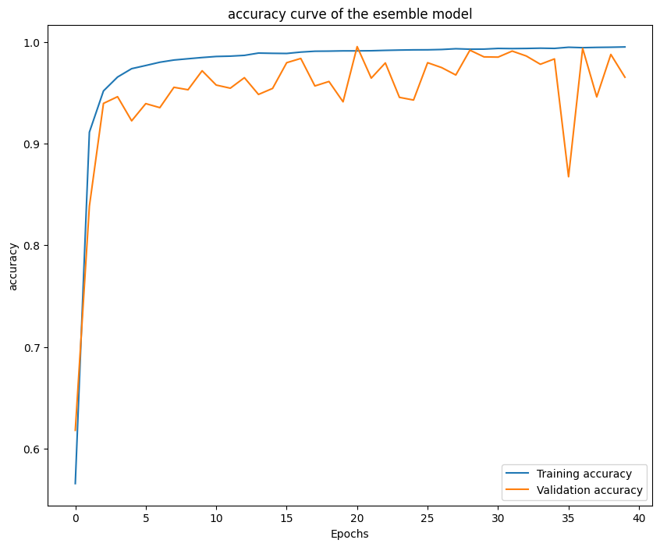

Figure 17. The Accuracy Curve of The Ensemble Model in Training and Validation

As can be seen from Figure 17, the training accuracy gradually increases throughout the training process apart from the first epoch where the model is initially learning the characteristics of the input images. Towards the end of training, the model's accuracy stabilizes at 0.996, demonstrating its excellent classification performance. This is also reflected in its performance on the validation set. Although some fluctuations in the validation set's accuracy curve, the model's accuracy exceeds 0.98 in most of the later epochs. When assessing randomly selected data from the test set, the model achieves a classification accuracy of 0.9997, showing strong generalization capability.

**4.1.3 Precision**

Precision is similar to accuracy, but it focuses more on the model's predictive accuracy for positive cases. The dataset used in this report has an uneven number of samples, so a micro-precision approach is used to treat all samples equally, regardless of the differences between classes. The precision curve during training and validation is shown in Figure 18.

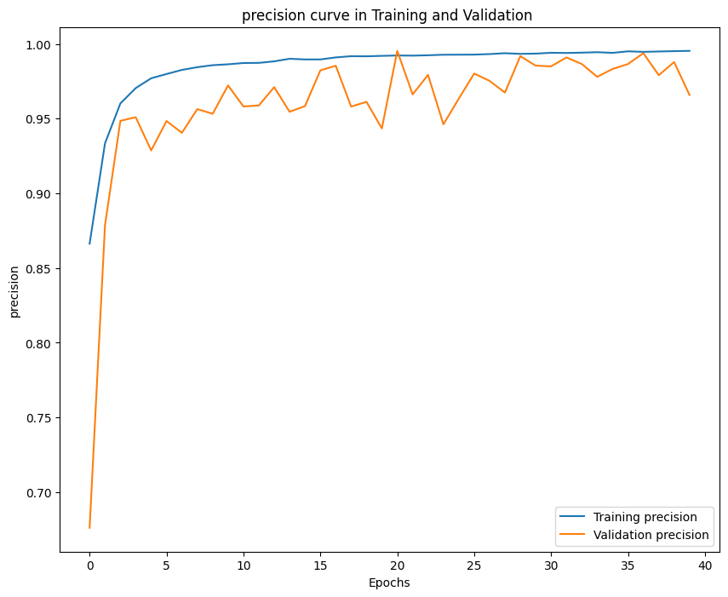

Figure 18. The Precision Curve of The Ensemble Model in Training and Validation

On the training set, the model's accuracy swiftly increased in the initial epochs, then gradually stabilized and remained at a high level, ultimately nearing 1. Compared to training accuracy, validation accuracy also rose rapidly at the beginning of training. But it experiences a decline after hitting a peak, followed by another ascent and remains at a comparatively elevated level. This type of fluctuation could signify alterations in the model's generalization capacity when it encounters new data, but in general, the validation accuracy is comparatively high. The accuracy on the test set also reached 0.9844, demonstrating that the model has good predictive ability for new data.

**4.1.4 Recall（Sensitivity）**

As the equation 3-8, recall measures the proportion of true positives correctly identified by the model. It's mainly applicable in scenarios where identifying positives is critical, such as in medical diagnostics. Sensitivity, primarily used in the medical field, is often considered the same as recall due to the identical calculation equation. The recall curve for this model is shown in Figure 19.

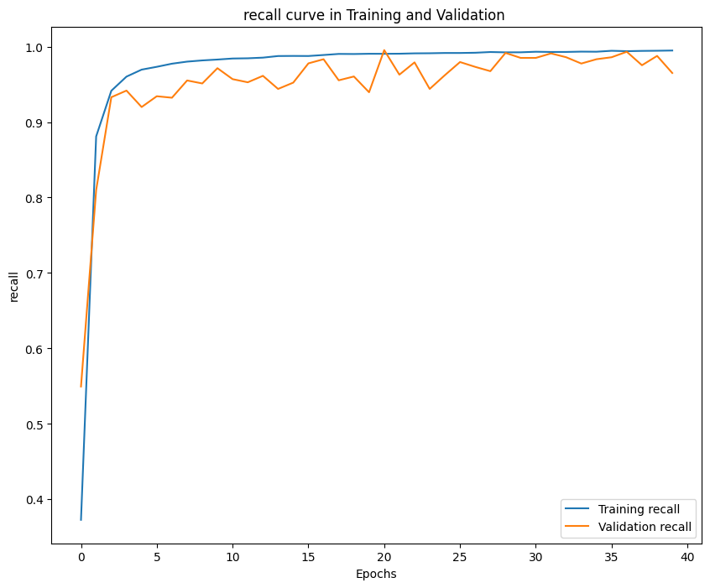

Figure 19. The Recall Curve of The Ensemble Model in Training and Validation

The validation recall rate trend is similar to the training recall rate, starting with a rapid increase and then fluctuating at a high level, although usually slightly lower than the training recall rate. On the test set, the model's recall can reach 0.9844, indicating that the model can also classify new images effectively.

**4.1.5 Specificity**

Specificity, defined in equation 3-9, focuses on the model's ability to identify negative cases, corresponding to the recall rate's focus on positive cases. The values of various evaluation metrics for this model are shown in Figure 20.

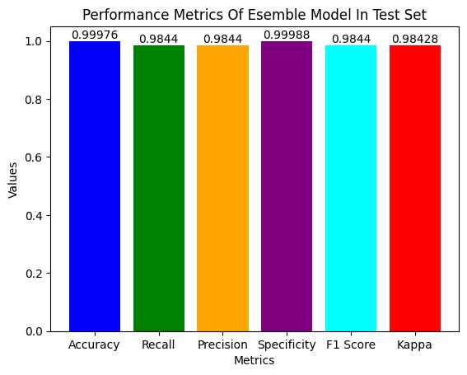

Figure 20. Accuracy, Recall, Precision, Specificity, F1-score and Kappa of The Ensemble Model in Training

As can be seen from the figure, the specificity value of the model is 0.998, indicating that the model has an excellent ability to filter negative cases, reducing the likelihood of misclassifying instances that do not belong to a certain class.

**4.1.6 F1-score**

As shown in equation 3-10, the F1-score integrates the metrics of precision and recall, providing a more holistic evaluation of the model's overall performance. Particularly in dataset like Fruits-360, where there is an imbalance in class distribution, it can more effectively demonstrate the model's ability to classify. Figure 20 shows that the model's F1-score on the test dataset is 0.9843, indicating a good balance between precision and recall, and a strong robustness to noise.

**4.1.7 Kappa**

As outlined in equation 3-11, Kappa considers the impact of random classification in its evaluation, assessing the superiority of the model's predictive results over random predictions. Furthermore, in classifications with imbalanced classes, Kappa avoids biases that may arise from classes with substantial data, correcting for accuracy biases caused by class imbalance. As shown in Figure 20, the model's Kappa is 0.9842, indicating high consistency between the model's classification results and actual outcomes, and effective handling of random selection and errors in predicted categories.

**4.1.8 Confusion Matrix**

The confusion matrix is a crucial evaluation metric in multi-classification problems, detailing the predicted categories of each image in the test set and visually demonstrating the model's classification ability for each class. The confusion matrix of this model is shown in Figure 21.

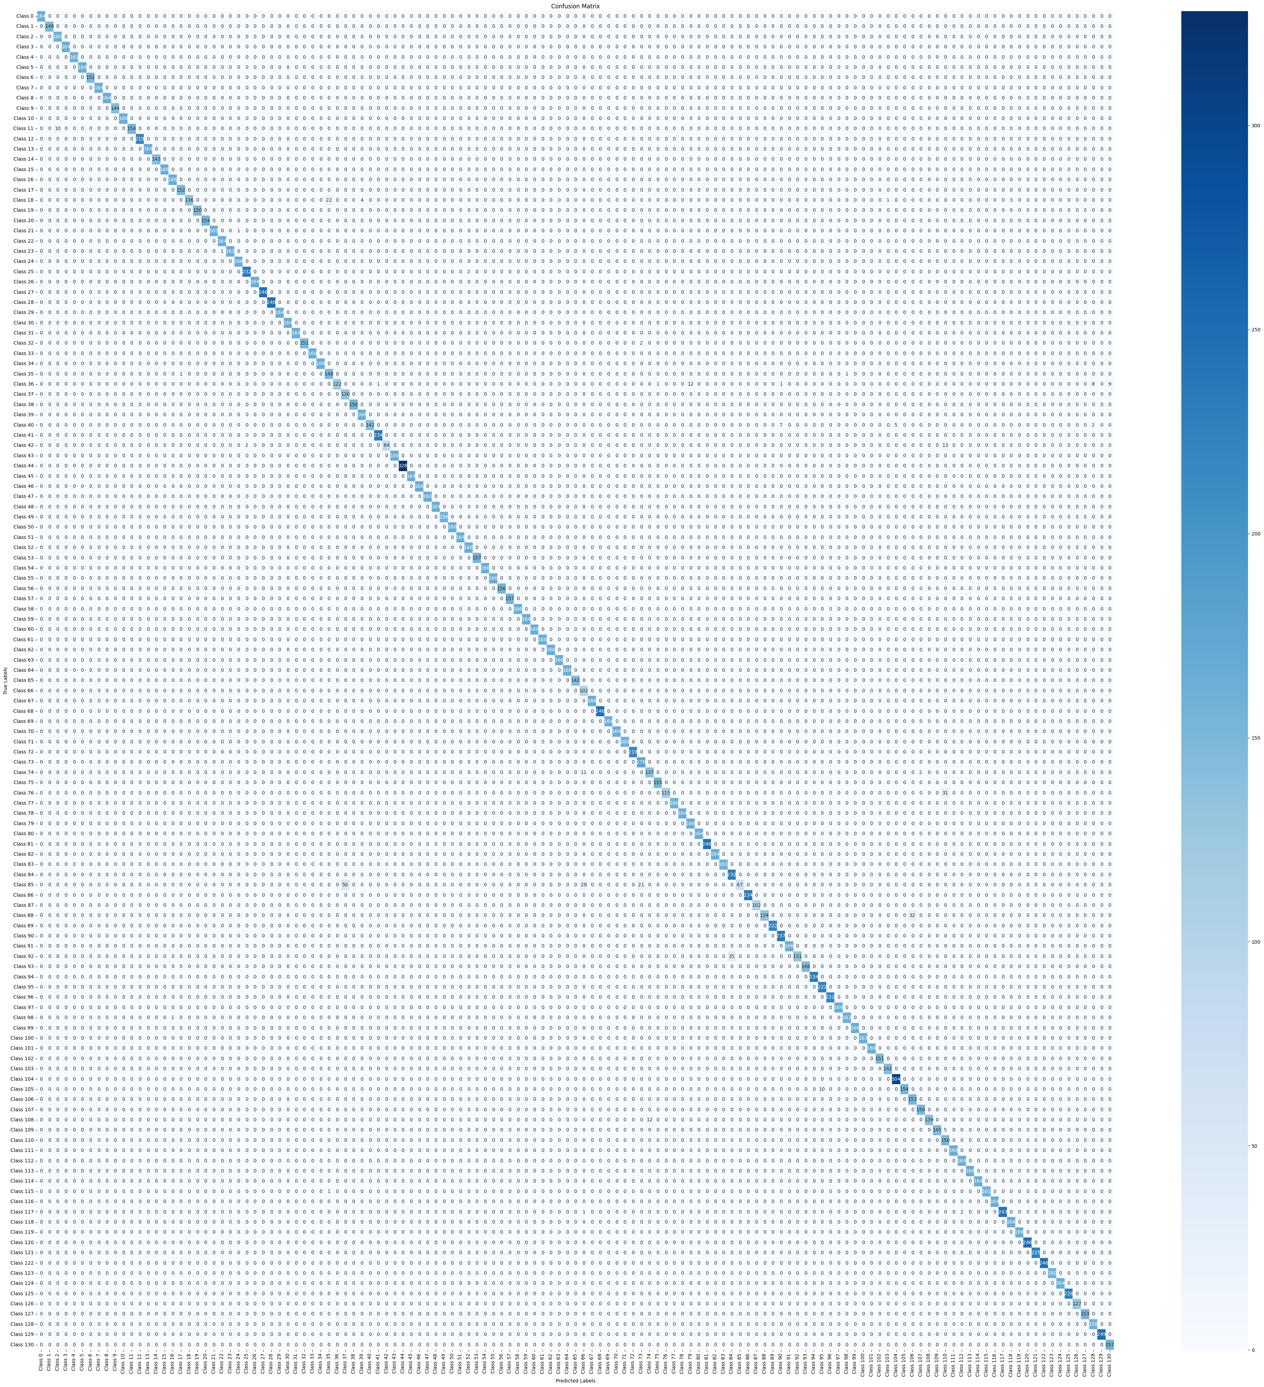

Figure 21. The Confusion Matrix of Ensemble Model in Test Set

From the figure, it's evident that the darker colors along the confusion matrix diagonal signify the correct classification of most samples. Although there are classification errors in some classes, the overall model exhibits a robust ability to distinguish between classes, facilitating precise multi-class classification.

**4.1.9 ROC-AUC curve**

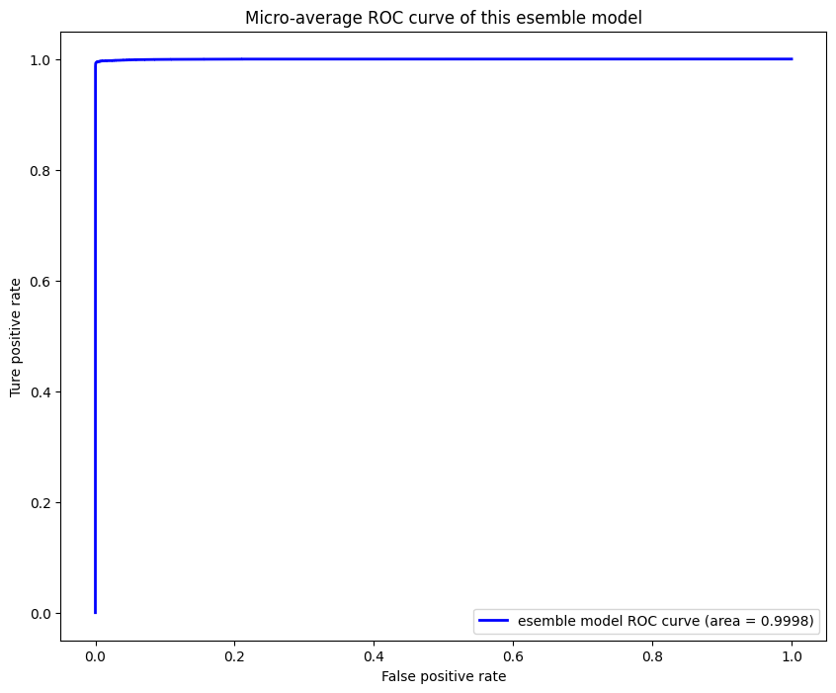

Figure 22. The ROC Curve of The Ensemble Model in Test set

The ROC curve is plotted with the False Positive Rate (FPR) on the x-axis and the True Positive Rate (TPR) rate on the y-axis. Unaffected by class distribution, the ROC curve directly reflects the model's performance across different classes. The area under the ROC curve is a standard for evaluating model performance, with a larger area indicating better performance. In this model, a micro-average approach merges the results of all classes to compute the overall TPR and FPR. Figure 22 shows that the ROC curve rapidly ascends to the TPR close to 1, signifying that the model attains a high TPR even with a low FPR. The area under the curve for this model is 0.9998, very close to 1, demonstrating that the model effectively distinguishes between classes, achieving high classification performance.

**4.1.10 Precision-Recall curve**

The Precision-Recall (PR) curve is drawn with recall on the horizontal axis and precision on the vertical axis, is chiefly utilized for assessing models. In cases of imbalanced class distribution, a high accuracy rate may be due to the model's excessive bias towards negative examples. Unlike accuracy, the PR curve is not influenced by negative examples. In this report, a micro-average PR curve is used to consolidate all classes, thereby evaluating the model's overall performance. The ensemble model's PR curve, as shown in Figure 23, extends steadily at a high level of precision, maintaining a very high accuracy rate. The area under the curve is 0.995, indicating that the model maintains a balance between precision and recall for most threshold settings.

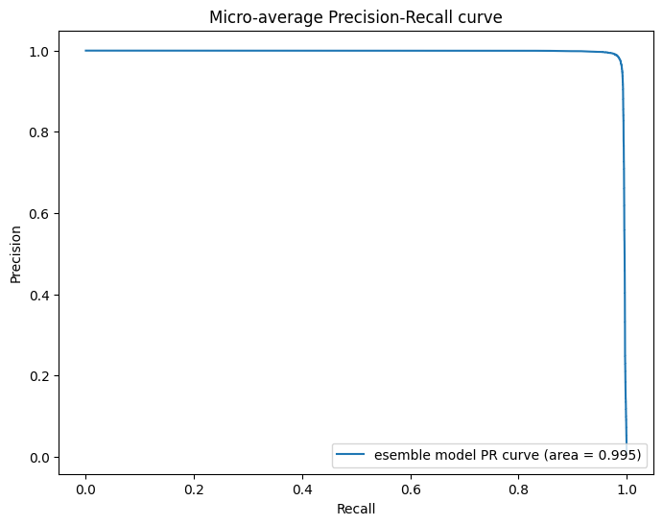

Figure 23. The Precision-Recall Curve of The Ensemble Model in Test set

**4.1.11 Heat Map**

The two sub-models in this ensemble model have integrated SE attention mechanisms to assign greater weight to significant features, so the Gradient-weighted Class Activation Mapping (Grad-CAM) technology is used to visualize the areas focused on by the ensemble model. Heatmaps are generated from the model's gradient information, where the color of each area represents its contribution to the classification result. Brighter colors signify a higher contribution level. The heatmap generated by this model is shown in Figure 24.

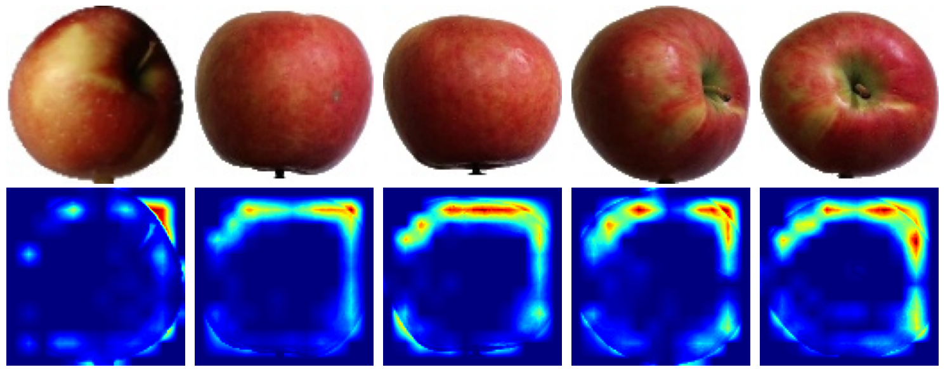

Figure 24. The Heat Map of The Attention Area of The Ensemble Model

In the heatmap, the first row shows the original images from the dataset, and the second row shows the heatmaps generated using Grad-CAM technology. Here, the brighter colors indicate areas focused on by the model during prediction, with red and yellow areas showing high levels of attention. In the apple images, the heatmap shows the model's primary focus on the apple's edges and certain distinct areas, typically associated with the fruit's classification and differentiation from other subtypes, demonstrating the attention mechanism's effective feature extraction and improved model generalization.

## **4.2. Discussion**

The evaluation metrics reveal that the ensemble model designed in this report demonstrates exceptional classification performance. The accuracy on the test set is as high as 99.97%, which proves the robust possessing potent feature extraction and generalization abilities, accurately categorizing the majority of fruit images. Additionally, the F1-score of 0.9844 also signifies that the model maintains high performance in imbalanced datasets, which is of significant importance in practical applications.

However, the dataset's uneven distribution still affects the model's performance, especially in terms of recall and precision. The model's recall and precision are relatively lower compared to its accuracy, both at 98.44%. This indicates that the model still has some degree of misclassification issues in certain specific classes. In addition, although the data division ratio (70%:5%:25%) helps to enhance the generalization ability of the model, it also results in a small amount of data in the validation set, with only 4527 images. As a result, the validation accuracy is susceptible to fluctuation due to an individual misclassification, which also explains why the accuracy of the validation set is generally equal to or lower than the training accuracy.

Despite this, the model's overall performance is still excellent, especially as the area under the ROC curve and the PR curve surpasses 0.99, which exhibits model's accuracy in classifying various fruit images and its robust capability to prevent misclassification, proving its efficacy and reliability.

**4.3 Fair comparison with other Deep Learning Models**

This study selected four popular models with strong performance in image classification to compare with the ensemble model proposed in this report. VGG16, MobileNet, ResNet50, and InceptionV3 are trained on the same dataset and followed identical training procedures on the same computational resources, aiming to identify the contributions and strengths of the ensemble model through comparison. The experiment's evaluation metrics are presented in Table 1.

**Table 1**. Evaluation results of each popular CNN model trained with Fruits-360 dataset

|  |  |  |  |  |  |  |  |  |  |
| --- | --- | --- | --- | --- | --- | --- | --- | --- | --- |
| **AI Model** | **Loss** | **Accuracy** | **Prediction** | **Recall** | **F1-score** | **Specificity** | **Kappa** | **ROC-AUV** | **PRC-AUV** |
| MobileNet | 0.2865 | 0.9600 | 0.9616 | 0.9595 | 0.961 | 0.9997 | 0.9597 | 0.9993 | 0.983 |
| InceptionV3 | 0.6824 | 0.9422 | 0.9444 | 0.9394 | 0.942 | 0.9996 | 0.9418 | 0.9849 | 0.945 |
| ResNet50 | 0.5528 | 0.9623 | 0.9626 | 0.9623 | 0.962 | 0.9997 | 0.9620 | 0.9921 | 0.973 |
| VGG16 | 22.8572 | 0.0073 | 0.0073 | 0.0073 | 0.007 | 0.9924 | 0.0003 | 0.4996 | 0.011 |
| Ensemble | **0.1380** | **0.9844** | **0.9844** | **0.9843** | **0.985** | **0.9999** | **0.9843** | **0.9998** | **0.995** |

From Table 1, it is evident that VGG16 demonstrates extremely poor classification performance on this dataset, as reflected in all its low metrics. Among these, the loss value reached 22.8572, the highest among all models, suggesting its ineffectiveness in learning features from input data and fitting the training data. The model's accuracy, being the lowest at 0.0073, implies it can scarcely classify any fruit images correctly. Other metrics like precision and recall are also low, further confirming the model's poor classification performance for fruits on this dataset and under these computational resources. A possible reason for this issue could be the RMSprop optimizer's initial learning rate of 0.001 is too high for VGG16 model, results in the model still being unable to converge after multiple training epochs. Another potential cause might be the use of two batch normalization layers and two dropout layers in the model's final layers, leading to excessive feature loss in the VGG16 model and preventing it from learning the characteristics of different fruits.

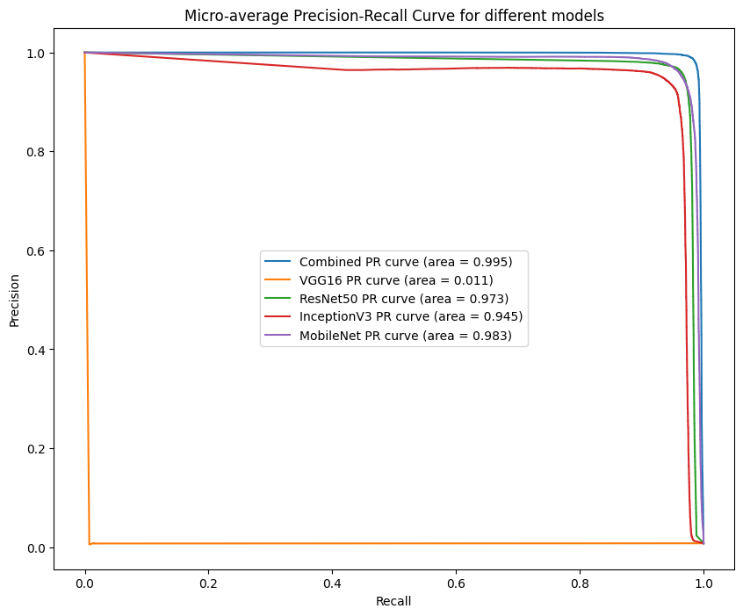

Figure 25. The Precision-Recall Curve of Five Models In Fruits-360 Dataset

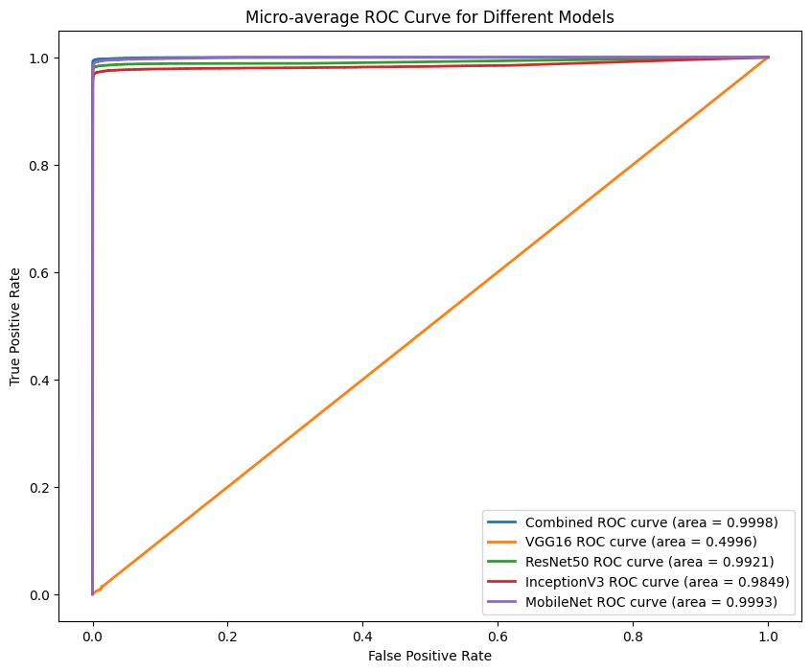

Figure 26. The ROC Curve of Five Models In Fruits-360 Dataset

As indicated by Figures 25 and Figure 26, MobileNet, ResNet50, InceptionV3, and the ensemble model successfully classify the input fruit images. The area under InceptionV3's PR curve is 0.945, a bit lower than the ensemble model’s 0.995, suggesting that InceptionV3 does not balance precision and recall as effectively as the ensemble model, and may trade off recall for greater precision in certain scenarios. The areas under the curves for MobileNet and ResNet50 are 0.983 and 0.973 respectively, just below the ensemble model, but they still demonstrate a high standard of classification.

The performance shown in the ROC figure is similar to the PR figure. VGG16's area under the curve is close to 0.5, indicating an almost random guessing level of accuracy in correctly distinguishing image classes. with VGG16's area under the curve near 0.5, indicating an almost random guessing level of accuracy in correctly distinguishing image categories. InceptionV3's area under the ROC curve is 0.9948, slightly lower than the other three models, indicating it may have more misjudgments in distinguishing fruit classes. ResNet50's area under the curve, at 0.9921, surpassing InceptionV3, demonstrates its strong classification capability in most fruit pictures. The AUC for MobileNet is very similar to the AUC for ensemble model, with both models balancing sensitivity and specificity well. But the AUC of ensemble model is 0.998, which is a little higher than MobileNet’s AUC, demonstrating superior discrimination ability.

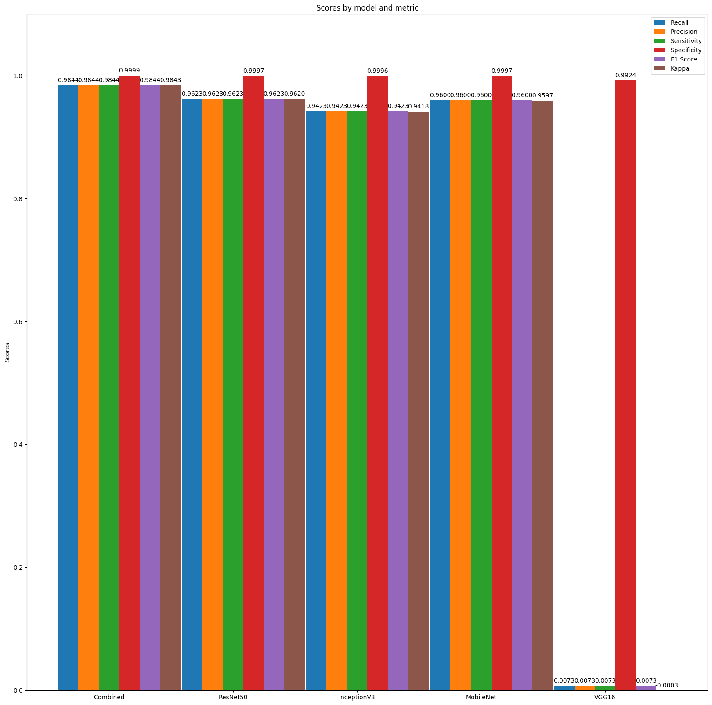

Figure 27. Recall, Precision, Sensitivity, Specificity, F1-score and Kappa of Four Models

The comparative evaluation metrics of each model are intuitively presented in Figure 27, clearly showing that the ensemble model has the highest values in Accuracy, Recall, Precision, Specificity, and Kappa. This confirms the outstanding performance of the ensemble model proposed in this report, adeptly handling multi-class fruit classification tasks and offering significant practical and operational value.

## **4.4 Indirect comparison With Existing Literature**

Fruits-360, as a dataset with 131 classes, covers a wide range of fruit types, making it less suitable for research in some specific fields, leading to some studies only selecting certain categories of images for their research. Bandyopadhyay et al. [16] selected 41 most common classes to train their custom CNN model with 15 hidden layers, achieving a final test accuracy of 97.48%, slightly lower than our proposed model. Chung & Tai [17] trained 25 classes with a total of 17,624 images using EfficientNet-B0, achieving an accuracy of 95.67%. However, as the authors used a lightweight model, there is a certain gap in recognition accuracy compared to our ensemble model. Joseph et al. [18] conducted their study using all images in Fruits-360 dataset. Their constructed model included 5 convolutional and 5 max pooling layers. Although the training accuracy reached 99.32%, the test accuracy was only 94.35%, indicating that their model still had overfitting issues. Jain & Chawla [19] spited Fruits-360 dataset into ratios of 80%, 10%, and 10%, training the InceptionV3 model's bottleneck layer for 4000 iterations, resulting in a final accuracy of 94.9%. Possibly due to the lack of dataset preprocessing, its accuracy is lower than the ensemble model. Muresan & Oltean [15] constructed an 11-layer model using alternating convolutional layers with 5x5 kernel and max pooling layers with 2x2 pooling kernel. However, their use of four large-kernel convolutional layers led to overfitting of the model. Despite a training set accuracy of 99.58%, the highest test set accuracy was only 95.23%, indicating the model's excessive focus on irrelevant features of training images and lack of generalization.

**Table 2**. Evaluation results of CNN Models proposed in Existing Literatures Using Fruits-360 Dataset

|  |  |  |  |  |  |  |  |  |  |
| --- | --- | --- | --- | --- | --- | --- | --- | --- | --- |
| Different schemes | Loss | Accuracy | Prediction | Recall | F1-score | Specificity | Kappa | ROC-AUV | PRC-AUV |
| Jain & Chawla[19] | x | 0.9490 | x | x | x | x | x | x | x |
| Joseph et al.[18] | x | 0.9435 | x | x | x | x | x | x | x |
| Muresan & Oltean[15] | x | 0.9523 | x | x | x | x | x | x | x |
| Chung & Tai [15] | x | 0.9567 | x | x | x | x | x | x | x |
| Bandyopadhyay et al.[16] | x | 0.9748 | x | x | x | x | x | x | x |
| Ensemble | 0.1380 | 0.9844 | 0.9844 | 0.9843 | 0.985 | 0.9999 | 0.9843 | 0.9998 | 0.995 |

A more direct comparison is shown in Table 2. Overall, the model proposed in this paper not only mitigates overfitting issues by incorporating BN and dropout layers but also demonstrates superior performance in feature extraction and generalization.

# **5. Conclusion**

In this study, we improved the Inception module with asymmetric convolution and the ResNet module with depthwise separable convolution, constructing two distinct CNN models. After integrating the SE attention mechanism, these were combined to form a new ensemble model. Through various comparative experiments, we identified suitable data preprocessing steps and hyperparameters. Then, use ten image classification metrics to evaluate the ensemble model with the accuracy of 99.97% and the F1-score of 0.9884. By comparing with other popular CNN models and previously proposed fruit classification models, our model demonstrated strong recognition accuracy for multiple fruit classes. Although our study has drawn rich empirical conclusions, several limitations need to be noted regarding the present study. One limitation is the uneven distribution of classes in the fruits-360 dataset, making it difficult for the model to effectively learn features of each class during training. Another limitation is that the model's training accuracy stabilizes at 99.6% after several epochs, indicating that the deep features of the input image can still be further extracted by improving the network architecture and hyperparameters of each layer. More broadly, research is also needed to use more efficient data augmentation methods to expand the dataset or find multi-category fruit datasets with more images. After addressing the issue of multi-class fruit classification, continued efforts are necessary to explore the identification and classification of multiple fruits.

**References**

[1] G. R. Machado, E. Silva, and R. R. Goldschmidt, ‘Adversarial machine learning in image classification: A survey toward the defender’s perspective’, *ACM Computing Surveys (CSUR)*, vol. 55, no. 1, pp. 1–38, 2021.

[2] K. He, X. Zhang, S. Ren, and J. Sun, ‘Deep residual learning for image recognition’, in *Proceedings of the IEEE conference on computer vision and pattern recognition*, 2016, pp. 770–778.

[3] J. Hu, L. Shen, and G. Sun, ‘Squeeze-and-excitation networks’, in *Proceedings of the IEEE conference on computer vision and pattern recognition*, 2018, pp. 7132–7141.

[4] N. Ekramirad, A. A. Adedeji, and R. Alimardani, ‘A review of non-destructive methods for detection of insect infestation in fruits and vegetables’, *Innovations in Food Research*, vol. 2, no. 1, pp. 6–12, 2016.

[5] M. S. Hossain, M. Al-Hammadi, and G. Muhammad, ‘Automatic fruit classification using deep learning for industrial applications’, *IEEE transactions on industrial informatics*, vol. 15, no. 2, pp. 1027–1034, 2018.

[6] J. Naranjo-Torres, M. Mora, R. Hernández-García, R. J. Barrientos, C. Fredes, and A. Valenzuela, ‘A review of convolutional neural network applied to fruit image processing’, *Applied Sciences*, vol. 10, no. 10, p. 3443, 2020.

[7] Y. Zhu *et al.*, ‘Classification of oolong tea varieties based on computer vision and convolutional neural networks’, *Journal of the Science of Food and Agriculture*, 2023.

[8] A. Krizhevsky, I. Sutskever, and G. E. Hinton, ‘ImageNet classification with deep convolutional neural networks’, *Communications of the ACM*, vol. 60, no. 6, pp. 84–90, 2017.

[9] K. Simonyan and A. Zisserman, ‘Very deep convolutional networks for large-scale image recognition’, *arXiv preprint arXiv:1409.1556*, 2014.

[10] R. Gruetzemacher and D. Paradice, ‘Deep transfer learning & beyond: Transformer language models in information systems research’, *ACM Computing Surveys (CSUR)*, vol. 54, no. 10s, pp. 1–35, 2022.

[11] F. Wang *et al.*, ‘Residual attention network for image classification’, in *Proceedings of the IEEE conference on computer vision and pattern recognition*, 2017, pp. 3156–3164.

[12] J. M. Haut, M. E. Paoletti, J. Plaza, A. Plaza, and J. Li, ‘Visual attention-driven hyperspectral image classification’, *IEEE transactions on geoscience and remote sensing*, vol. 57, no. 10, pp. 8065–8080, 2019.

[13] A. Dosovitskiy *et al.*, ‘An image is worth 16x16 words: Transformers for image recognition at scale’, *arXiv preprint arXiv:2010.11929*, 2020.

[14] Y.-D. Zhang *et al.*, ‘Image based fruit category classification by 13-layer deep convolutional neural network and data augmentation’, *Multimedia Tools and Applications*, vol. 78, pp. 3613–3632, 2019.

[15] H. Muresan and M. Oltean, ‘Fruit recognition from images using deep learning’, *Acta Universitatis Sapientiae, Informatica*, vol. 10, no. 1, pp. 26–42, 2018.

[16] A. Bandyopadhyay, S. Ghosh, M. Bose, L. Kessi, and L. Gaur, ‘Supervised Neural Networks for Fruit Identification’, in *International Conference on Recent Trends in Image Processing and Pattern Recognition*, Springer, 2022, pp. 220–230.

[17] D. Thi Phuong Chung and D. Van Tai, ‘A fruits recognition system based on a modern deep learning technique’, in *Journal of physics: conference series*, IOP Publishing, 2019, p. 012050.

[18] J. L. Joseph, V. A. Kumar, and S. P. Mathew, ‘Fruit classification using deep learning’, in *Innovations in Electrical and Electronic Engineering: Proceedings of ICEEE 2021*, Springer, 2021, pp. 807–817.

[19] P. Jain and P. Chawla, ‘Smart Module Design for Refrigerators based on Inception-V3 CNN Architecture’, in *2021 Second International Conference on Electronics and Sustainable Communication Systems (ICESC)*, 2021, pp. 1852–1859. doi: 10.1109/ICESC51422.2021.9532833.